**Agents:**

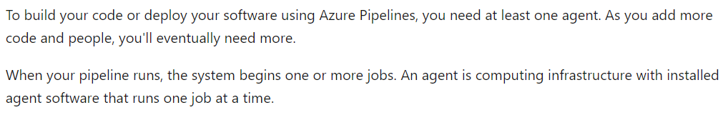

**Microsoft hosted agents:**

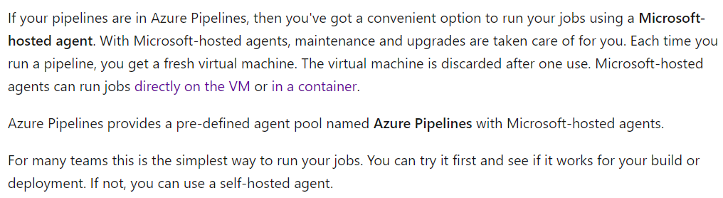

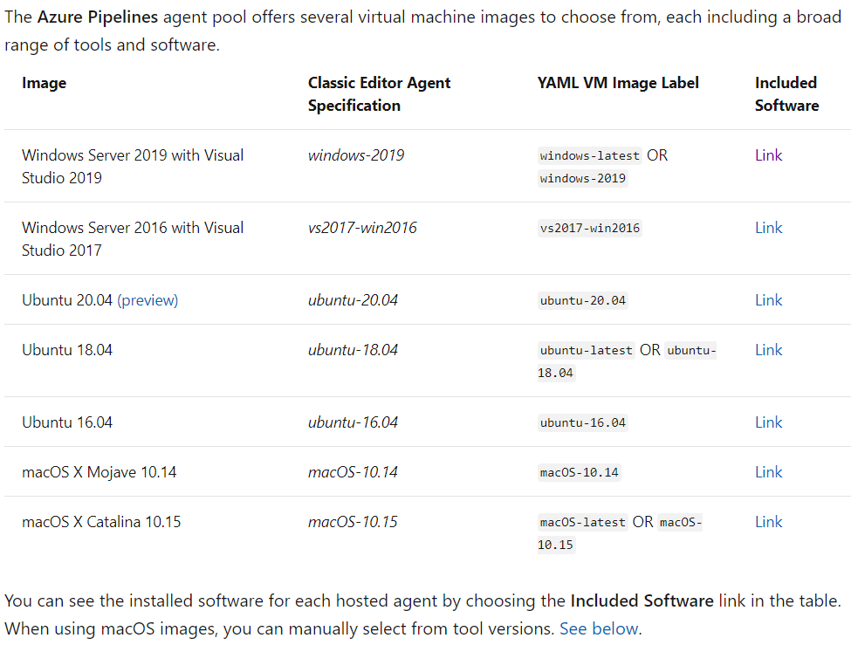

**Self-hosted agent:**

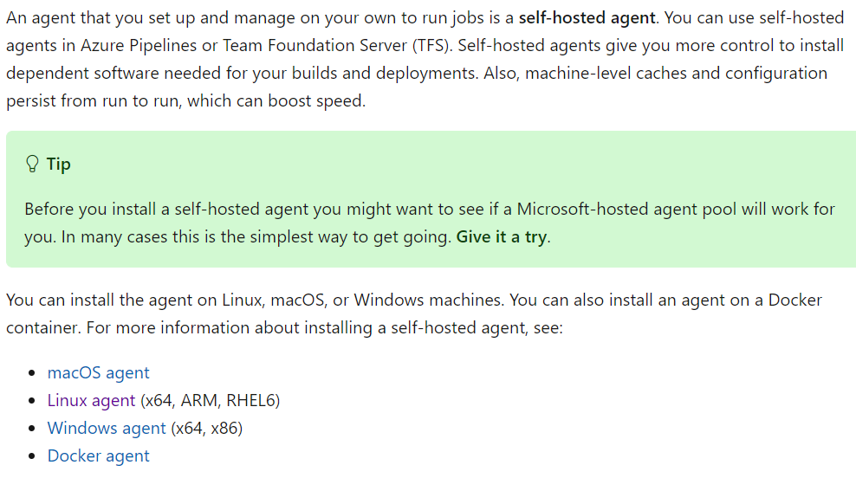

**Agent pools:**

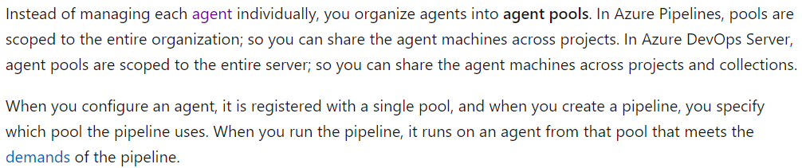

**Creating agent pool:**

* If we go to organisation settings or project settings. We can see the agent configuration under **“pipelines”** option as below.

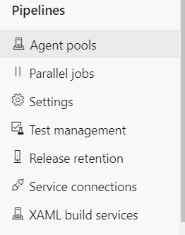

* Here, if we go to agent pools, we can see the below options.

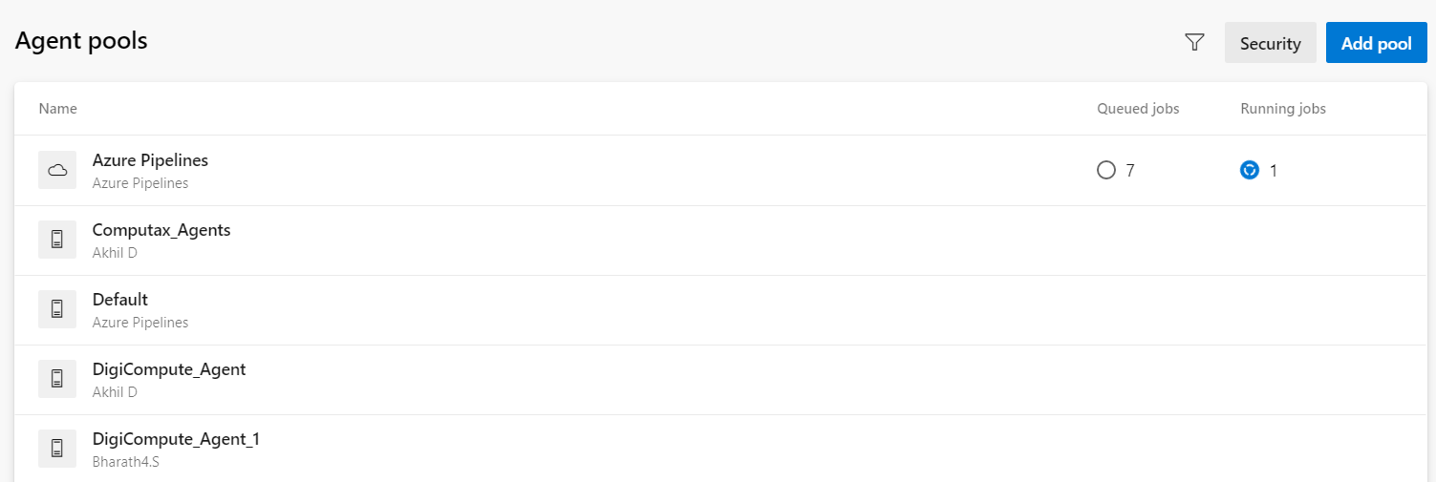

* We can add a new pool as below.

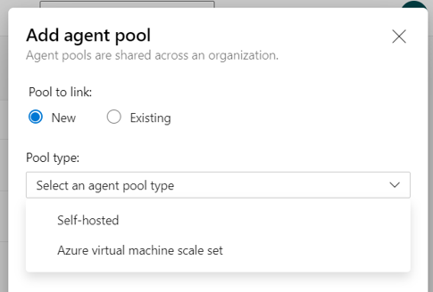

* Here we can create a new pool or use existing one.
* We can also add below permissions under **“security”** to all the pools. We can add the permissions to either users or groups.

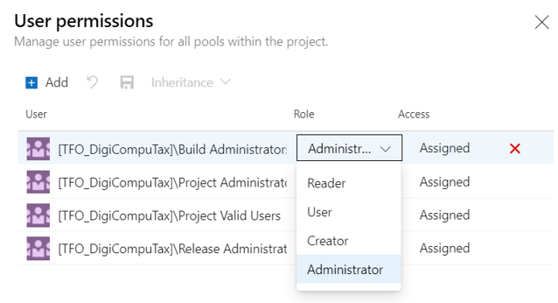

**Creating agent inside pool:**

* First, we need to create a token for authentication to install the agent.

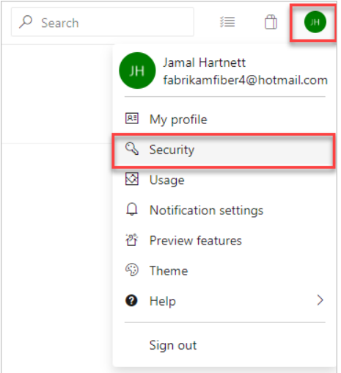

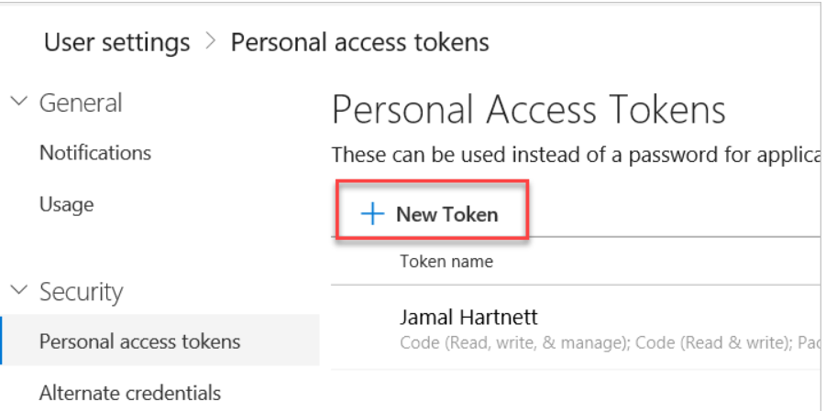

* We need to give it a name, expiry date, full access or custom defined on work items, code, releases etc. we have around 28 scopes to define the access.

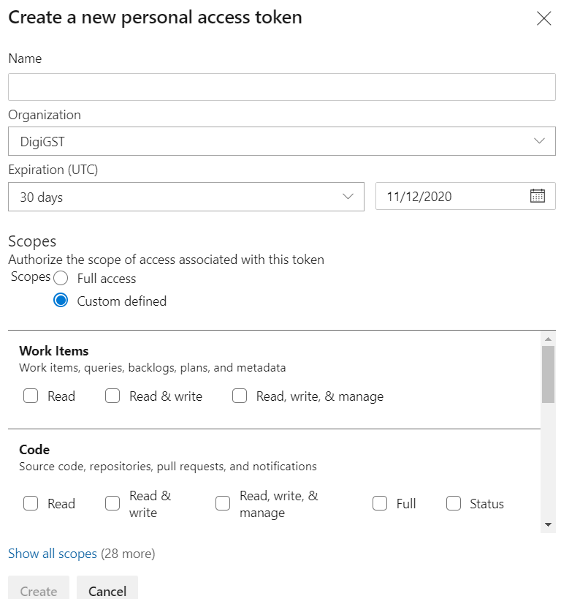

* For deployment group agent, PAT must have deployment group (read, manage) access scope.
* Once the token is created, we can open it and see the below details under **“agent”** option.

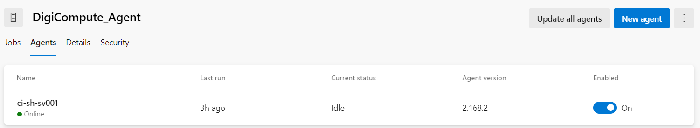

* Here, we can add new agent and follow the below steps based on the type of OS.
* Below are the steps for linux.

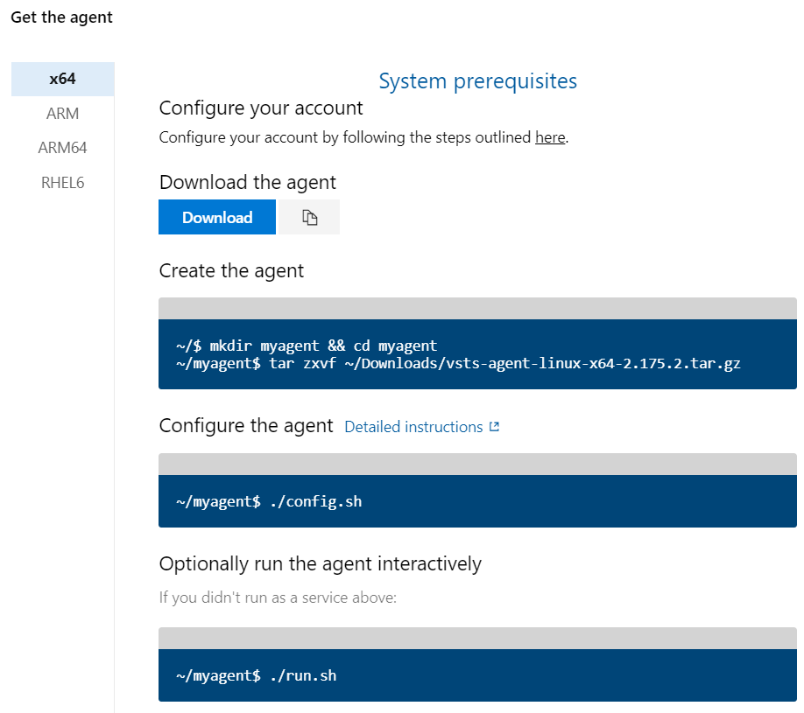

* We need to select PAT option and enter the key while running config.sh file. Below are the options.

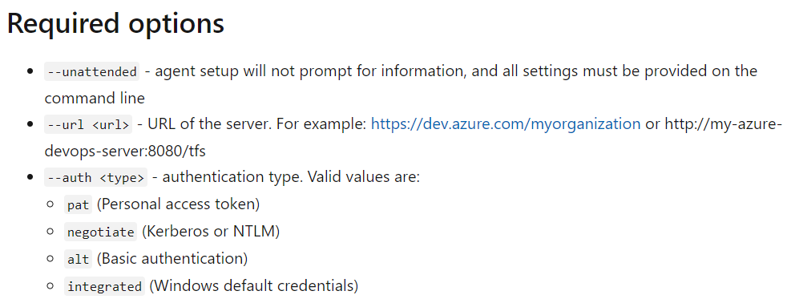

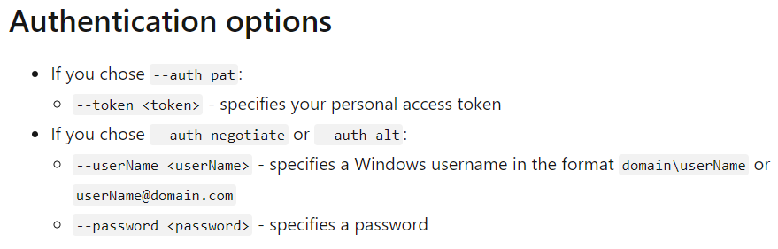

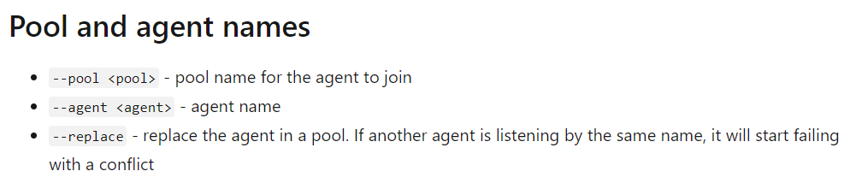

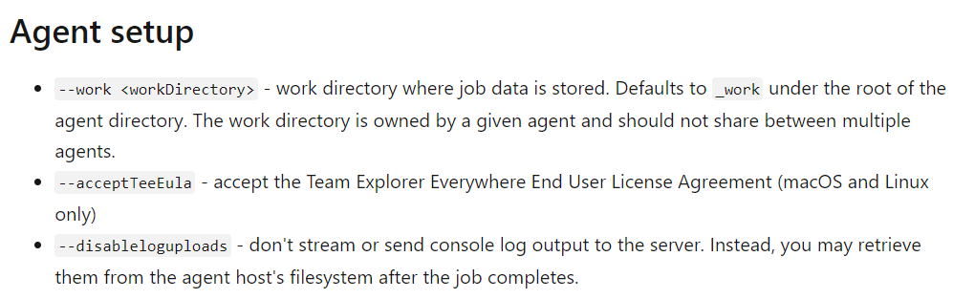

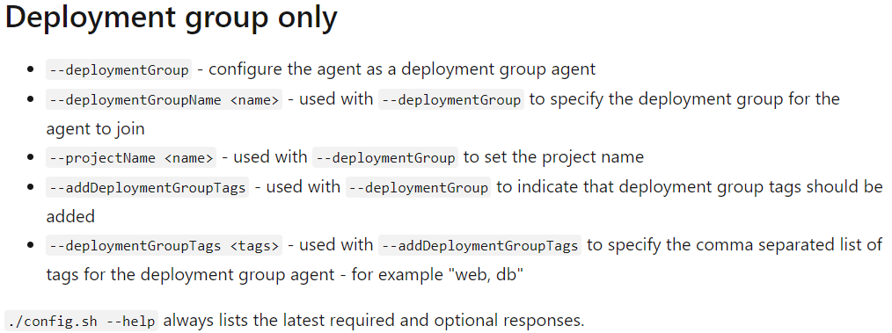

* Once it is done, we can see the agent is online in the portal and also, we can see the capabilities of the agent.

**Run the agent interactively:**

Below is the command to run an agent interactively

* **./run.sh**

If we want to run agent only once

* **./run.sh –once**

To remove the agent

* **./config.sh remove**

Running agent as a service:

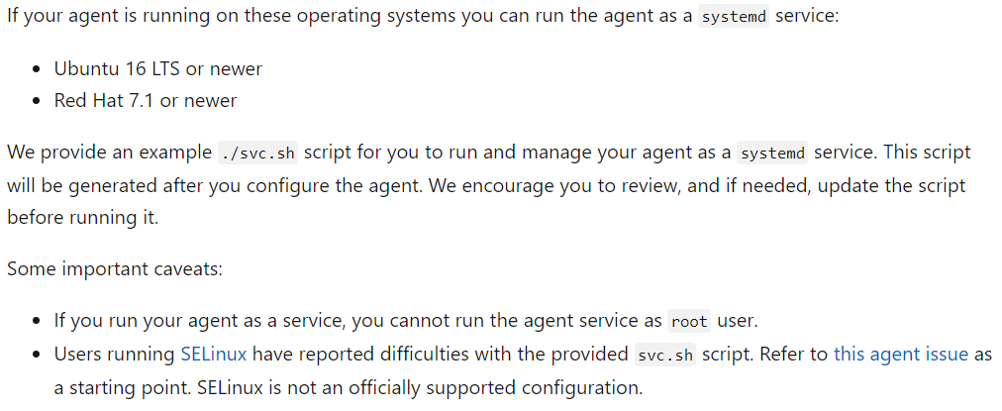

To install as a service

* **./svc.sh install**

This command creates a service file that points to **./runsvc.sh**. This script sets up the environment

To start the service

* **./svc.sh start**

To stop the service

* **./svc.sh stop**

To check the status

* **./svc.sh status**

To uninstall the service

* **./svc.sh uninstall**

Update environment variables:

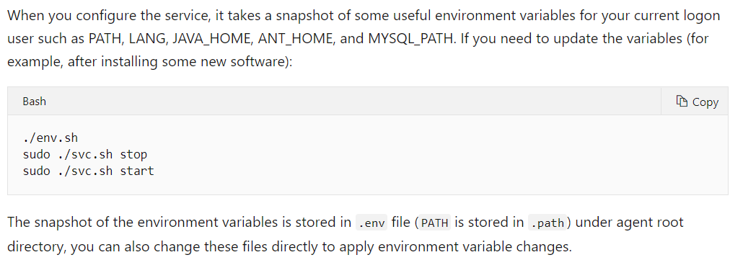

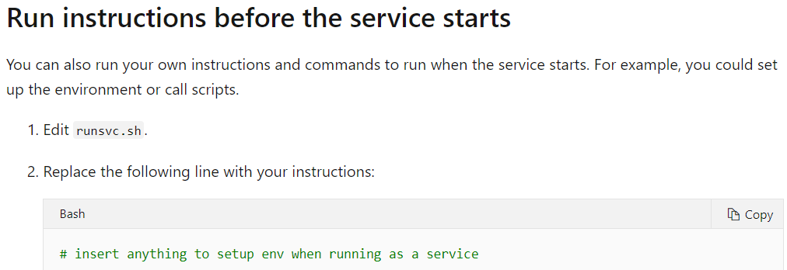

**Jobs:**

Under jobs section, we can see the completed or running jobs in the pool as below.

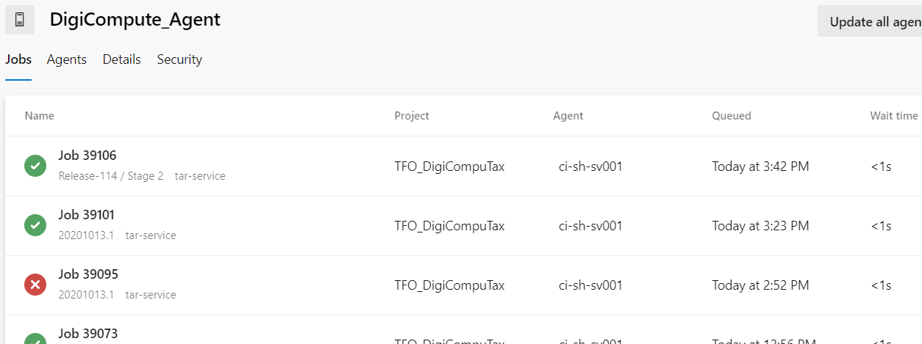

**Security:**

We can have permissions restricted here under “security” option as below.

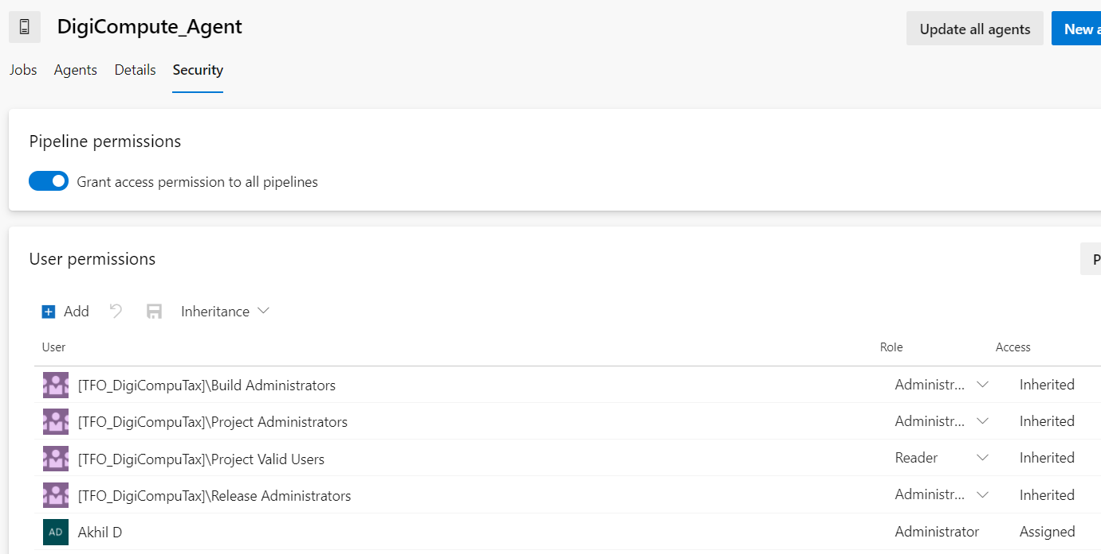

**Parallel jobs:**

